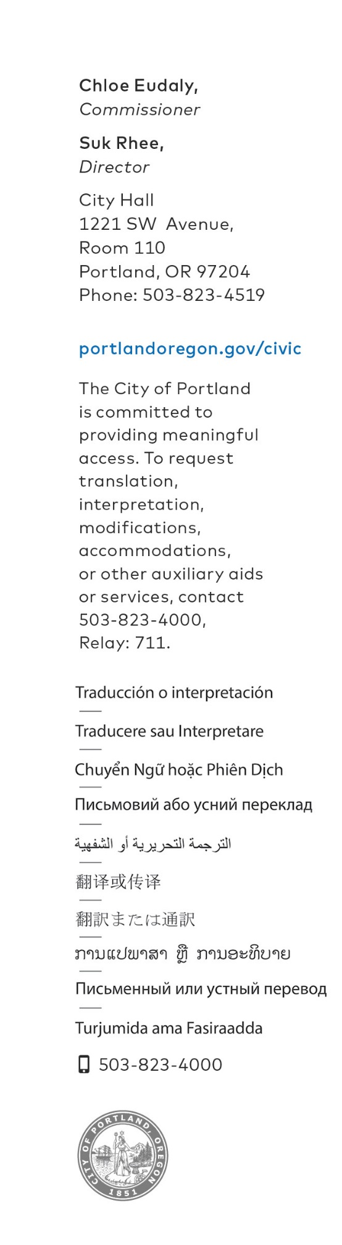
FOR IMMEDIATE RELEASE
May 18, 2020
MEDIA CONTACT: Margaux Weeke, 503-823-8603
margaux.weeke@portlandoregon.gov

City of Portland Awarded Research to Support Immigrant-inclusive COVID-19 Relief Measures.
Office of Community & Civic Life announces New American Economy
research support

Portland, Oregon – Since the onset of the COVID-19 pandemic, local leaders have been working tirelessly to ensure that all community members—and particularly the most vulnerable populations—have access to the services and support that they need. To support these local efforts, Civic Life is pleased to announce that the City of Portland is one of 12 local governments and nonprofits that have been selected to receive tailored research to inform culturally sensitive emergency response measures that ensure all residents are included, regardless of immigration status.

At no cost to the City, Portland will receive customized research reports that highlight the demographic nuances of our local immigrant communities and help identify gaps in service provision and challenges that are specific to each community.

This research will be used to support strategic efforts for immigrant-inclusive emergency response initiatives as the City continues to address the impacts of COVID-19 while meeting its equity goals.

“The COVID-19 crisis has demonstrated how vital it is to share culturally-specific communications in a timely manner—we need every Portlander to have access to life-saving information and social support,” said Commissioner Chloe Eudaly. “This New American Economy research will support our efforts to effectively reach Portland’s immigrant communities and to address gaps in federal programs.”

A full list of research recipients and more information about the New American Economy can be found here.

###

